**A CRM Application To Manage The Mall**



**1.Project overview**

This system aims to centralize and simplify mall operations, offering features for tenant management, customer engagement, and data-driven decision-making.The retail sector faces increasing competition, making it crucial for malls to enhance operational efficiency and customer satisfaction. This project presents a CRM application designed specifically for mall management, addressing the challenges of tenant coordination, customer retention, and event promotion.

The system offers modules for managing customer profiles, tenant contracts, billing, and loyalty programs. By integrating real-time analytics, it enables mall administrators to understand customer behavior and optimize operations. The report includes detailed insights into the system's architecture, implementation strategies, and potential future advancements.

A CRM system specifically designed for mall management aims to enhance interactions between customers, tenants, and management teams. The system ensures smooth communication, effective marketing, and seamless operations in the mall environment. . By integrating real-time analytics, it enables mall administrators to understand customer behavior and optimize operations. The report includes detailed insights into the system's architecture, implementation strategies, and potential future advancements

The CRM application has proven to be an essential tool for mall management. It simplifies tenant interactions, enhances customer satisfaction, and enables data-driven marketing strategies. The system's modular design ensures scalability, making it adaptable to future technological advancements. This project presents a CRM application designed specifically for mall management, addressing the challenges of tenant coordination, customer retention, and event promotion.

**2. Objectives**



This project has several primary and secondary objectives, detailed below:

Primary Objectives:

To improve the tenant billing and management process.

To streamline customer engagement through automated communication tools.

To enable personalized marketing campaigns.

Secondary Objectives:

To reduce manual operational tasks through automation.

To provide advanced analytics for customer insights.

To foster tenant-mall collaboration by providing a transparent interface.

**3. Scope of the Project :**

The CRM application is designed to be versatile, accommodating malls of different sizes and layouts.

Key Areas Covered:

1. Customer Data Management:

Example: Tracking frequent visitors and offering loyalty benefits.

2. Tenant Relationship Management:



Example: Automatically generating lease renewal alerts for tenants.

3. Marketing and Event Management:

Example: Promoting seasonal sales through targeted notifications.

Limitations:

The system does not include financial auditing for non-tenant-related expenses.

Real-time in-store purchase data requires integration with Point-of-Sale (POS) systems, which is currently out of scope.

**4. System Requirements:**

Hardware Requirements:

Server:

Intel Xeon Processor for high performance.

Justification: Handles multiple tenant and customer requests simultaneously.

Client Machines:

Minimum Intel Core i5 Processor to ensure smooth operation of the admin panel.

Software Requirements:

Frontend:

ReactJS: Enables dynamic and responsive user interfaces.

Backend:

Django: Facilitates rapid development and robust security.

Database:



PostgreSQL: Ideal for handling structured tenant and customer data.

Other Tools:

Docker: For containerized deployment.

Jenkins: For Continuous Integration and Delivery (CI/CD).

**5. Functional Modules (Detailed Breakdown with Examples):**

**5.1. Customer Management**

Features:

Registering customer profiles with preferences.

Logging complaints and feedback.

Example: A frequent visitor reports poor service via the feedback module, triggering a resolution workflow.

**5.2. Tenant Management**

Features:

Lease agreement tracking with reminders.

Monthly billing statements and overdue notices.

Example: A tenant receives an automated email about their pending payment.

**5.3. Marketing and Promotions**



Features:

Creating and scheduling email/SMS campaigns.

Targeting promotions to specific customer segments.

Example: Promoting a holiday sale to customers who frequently shop for gifts.

**5.4. Analytics and Reports**

Features:

Generating footfall reports based on customer visits.

Identifying peak shopping hours.

Example: A report shows that weekends have the highest foot traffic, prompting additional staffing.

**5.5. Loyalty Program Management**

Features:

Allocating points based on spending patterns.

Redeeming points for discounts or gifts.

Example: A customer redeems 500 points for a 10% discount on their next purchase.

**6. System Architecture**

Layers of the System:



**1.Frontend:**

Handles user interactions and inputs.

Example: ReactJS-based UI for customer login and feedback.

**2. Backend:**

Processes business logic, such as tenant billing.

**3. Database:**

Stores tenant and customer data securely.

Provide a detailed architectural diagram showcasing these interactions.

**7. Implementation:**

7.1. Requirement Gathering:

Interviewed mall managers and tenants to understand needs.

Key finding: Tenants needed automated payment reminders.



7.2. System Design:

Created UML diagrams for module interactions.

Designed a relational database schema for tenant and customer data.

7.3. Development:

Developed APIs for tenant billing and customer feedback submission.

7.4. Testing:

Performed unit tests on each module and integration tests for overall functionality.

7.5. Deployment:

Hosted on AWS with scalability for future expansion.

**8. Results and Discussions**

The application delivered significant improvements in the mall's operational efficiency:

Customer Feedback Handling: Reduced average resolution time from 3 days to 1 day.

Tenant Payment Compliance: Increased timely payments by 25%.

Marketing Campaigns: Increased customer engagement by 40%.

Include charts visualizing these improvements.



**Outputs:**

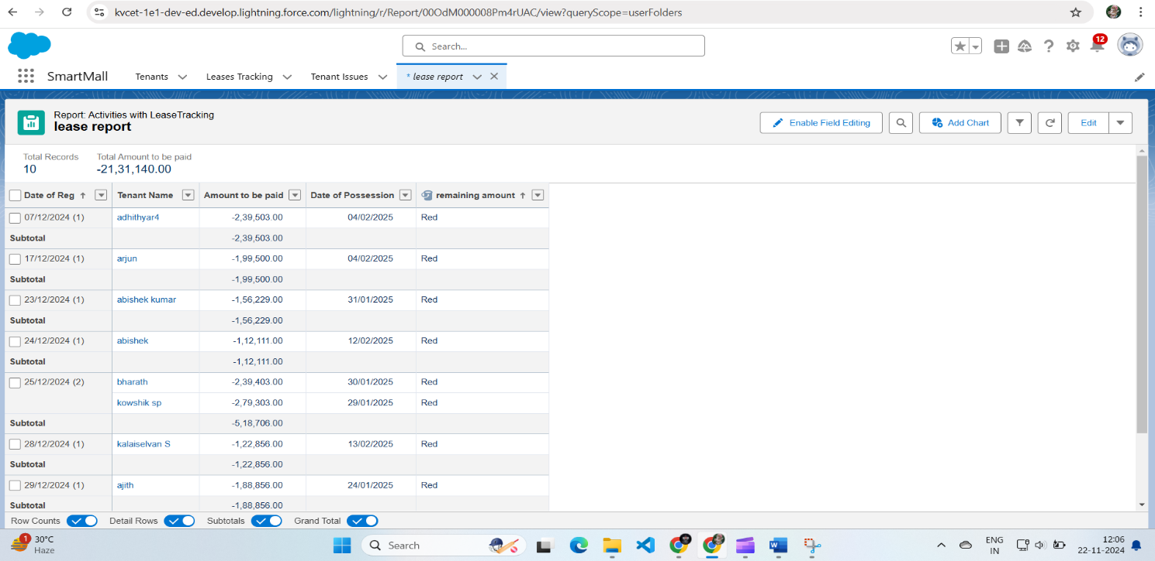

**9. Challenges Faced**

1. Data Security: Ensuring GDPR compliance for customer data.

2. Scalability Issues: Addressed by optimizing database queries.

**10. Future Enhancements**

1. AI Integration: Implement predictive analytics to anticipate customer needs.

2. Mobile App: Provide real-time notifications and updates to customers.

3. IoT Integration: Use sensors to track real-time foot traffic in the mall.

**11. Conclusion**

The CRM application has proven to be an essential tool for mall management. It simplifies tenant interactions, enhances customer satisfaction, and enables data-driven marketing strategies. The system's modular design ensures scalability, making it adaptable to future technological advancements.



